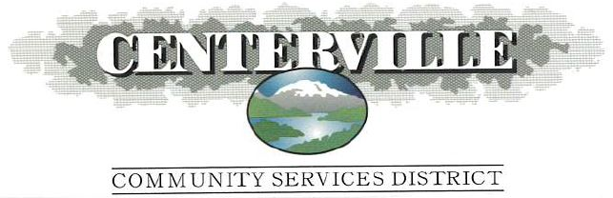

Regular Board Meeting of the Board of Directors
Wednesday, July 17, 2024 7:00 PM

AGENDA

TO ADDRESS THE BOARD DURING OPEN TIME OR NOTICED PUBLIC HEARINGS: pursuant to the Brown Act (Government Code Section 54950 et seq.) action or Board discussion can not be taken on open time matters other than to receive the comments, and if deemed necessary, to refer the subject matter to the District Manager for follow up and/or to schedule the matter on a subsequent Board agenda.

ITEM FUNCTION

PRELIMINARY BUSINESS

1 Call to Order
2 Public Comment Period – Open Time – This time is set for members of the public to address the Board on matters not on the agenda. If your comments concern an item noted on the regular agenda, please address the Board after that item is open for public comments. By law, the Board of Directors cannot discuss or make decisions on matters that are not on the agenda. The Board will customarily refer these matters to the District Manager’s Office. Each speaker is allocated (5) minutes to speak for a maximum of 20 minutes on each subject. Speakers may not cede their time. Comments should be limited to matters within the jurisdiction of the District. After receiving recognition from the Board President, please state your name and comments.
3 Approval of the minutes of:
June 19, 2024, Regular Board Meeting Action
4 Authorize Payment of Bills for Current Expenses Action
5 Status of the Budget Report Information

NEW BUSINESS

1 Public Hearing for the Board to Consider Adopting
a Final O&M Budget for FY 2024-25 as included in
Resolution 2024-06 Action

OLD BUSINESS

1 Muletown Pump Station Generator Project Update Information
2 Carr Fire Recovery Project Update Information

CLOSED SESSION

1 Annual review of District Manager’s Performance (§54957) Action

GENERAL BUSINESS

1 Correspondence Information
2 Director’s Report Information
3 Manager's Report Information
4 Committee Reports Information
5 Announcements
6 Adjournment

Next Scheduled Board Meeting
August 21, 2024 @ 7:00 P.M.

“This is an equal opportunity provider”

In compliance with the Americans with Disabilities Act, the Centerville Community Services District will make available to any member of the public who has a disability, a needed modification or accommodation, including an auxiliary aid or service, for that person to participate in the public meeting. A person needing assistance should contact the district office by telephone at (530) 246-0680, or in person or by mail at 8930 Placer Road, Redding, California 96001, or by e-mail at tteuscher@centervillecsd.com, at least two working days in advance. Accommodation may include, but are not limited to, interpreters, assistive listening devices, accessible seating, or documentation in an alternate format. If requested, this document and other agenda materials can be made available in an alternative format for persons with a disability who are covered by the Americans with Disabilities Act.

